


ISLAMIA UNIVERSITY OF BAHAWALPUR

Title: Mobile Sales Management System
(Tech wave)

Submitted By:
__M-Numan__
Submitted To:
_Prof:Abdul karim nawaz_
Roll No:
_S25BINFT7M04016_
Semester:
_7TH(1ST M)_
PROJECT:
Final year(Mobile selling purchasing app)

PROJECT PROPOSAL

Title: Mobile Sales Management System

1. Introduction
In today’s time, mobile phones are one of the most important devices in daily life. People prefer to explore and purchase mobile phones online because it is fast, easy, and saves time. However, many small businesses still depend on manual selling or social media platforms, which are not properly organized.
This project focuses on developing a Mobile Sales Management System, which will provide an online platform for customers to browse and purchase mobile phones, while also helping shop owners manage their products and orders efficiently.
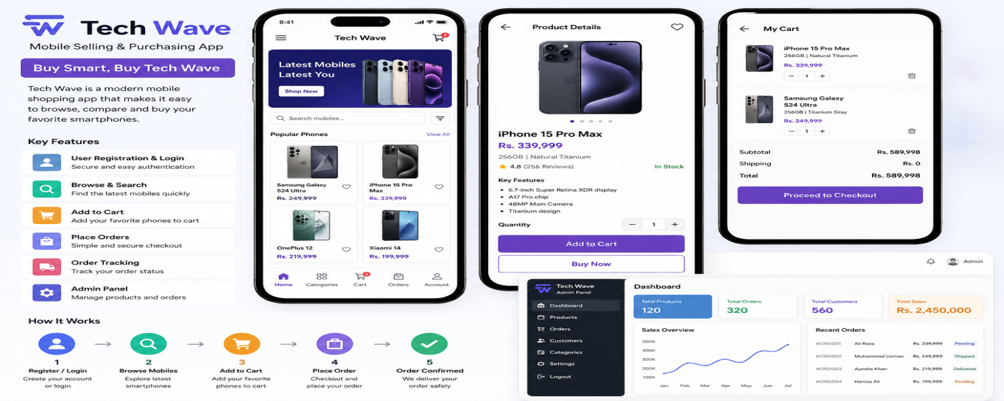

2. Purpose of the Project
The main purpose of this project is to design and develop a system that simplifies the process of buying and selling mobile phones.
This system will:
- Provide an organized platform for mobile sales
- Reduce manual work for shop owners
- Improve customer experience
- Maintain proper records of products and orders

3. Problem Statement
Currently, many mobile shops face the following problems:
- No proper system for managing products
- Difficulty in tracking orders
- Limited customer reach
- Time-consuming manual processes
- Lack of secure and reliable data storage
Because of these issues, both customers and shop owners face inconvenience. Therefore, a complete system is needed to solve these problems.

4. Objectives:
The main objectives of this project are:
- To develop an online mobile selling system
- To allow users to view and compare mobile phones
- To provide a smooth ordering process
- To help admins manage products and orders
- To ensure data is stored securely

5. Scope of the System:
The system will include:
- User registration and login
- Product browsing and searching
- Add to cart and checkout system
- Order management
- Admin control panel
The system is mainly designed for small to medium mobile businesses.

6. Proposed Solution:
The proposed solution is a web-based application where:
- Customers can create accounts and log in
- Users can browse available mobile phones
- Users can add products to cart and place orders
- Admin can manage product listings
- All data will be stored in a database
This system will make the selling process more efficient and organized.

7.Methodolgy:
To develop the Mobile Sales Management Application, a simple and organized approach will be used so that each step is completed properly. First, the basic requirements of the system will be understood, such as how users will log in, view products, and place orders. After that, the overall structure of the system will be planned to make sure everything is connected in the right way. Then, the application will be developed by creating the user interface and adding the main features. Once the system is ready, it will be tested to check if everything is working correctly and to fix any problems. In the final step, the application will be made available for users, and future updates can be added if required.

8.Development Tools:
- Visual Studio Code
- Git
- GitHub

Three layer of Architecture:
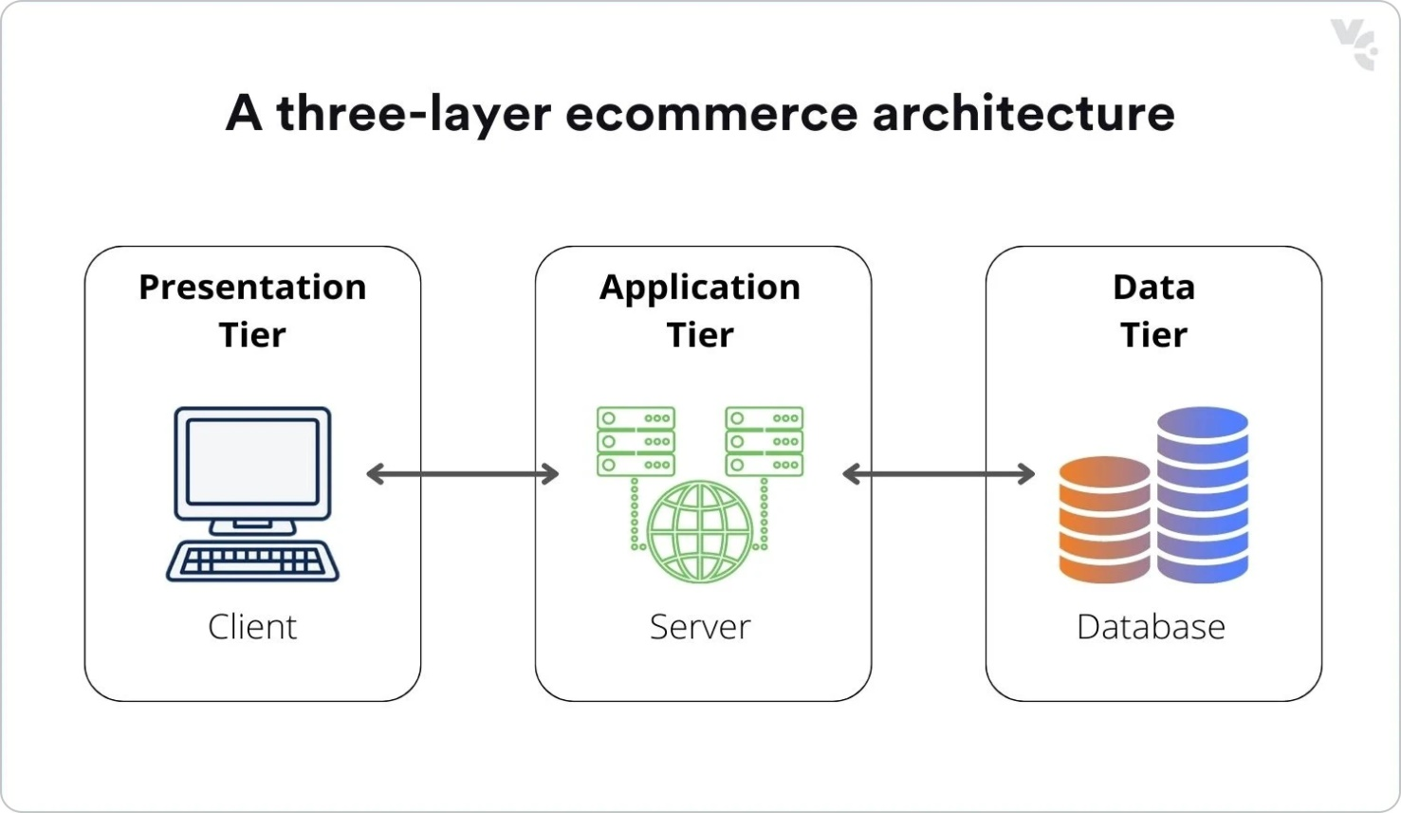

9. Key Features:

User Side Features
- Registration and login
- View mobile phones with details
- Search and filter products
- Add to cart
- Place orders

Admin Side Features
- Add new mobile products
- Update product details
- Delete products
- View and manage orders

10. Benefits of the System
This system will provide many benefits:

For Customers
- Easy access to mobile phones
- Time-saving
- Better product comparison
- Simple ordering process

For Shop Owners
- Better product management
- Organized data storage
- Increased sales opportunities
- Reduced manual work

11. System Users
- Customer: Can browse and purchase mobiles
- Admin: Manages products and orders

Customer:
  - Login
  - View Products
  - Add to Cart
  - Place Order

Admin:
  - Add Product
  - Update Product
  - Delete Product
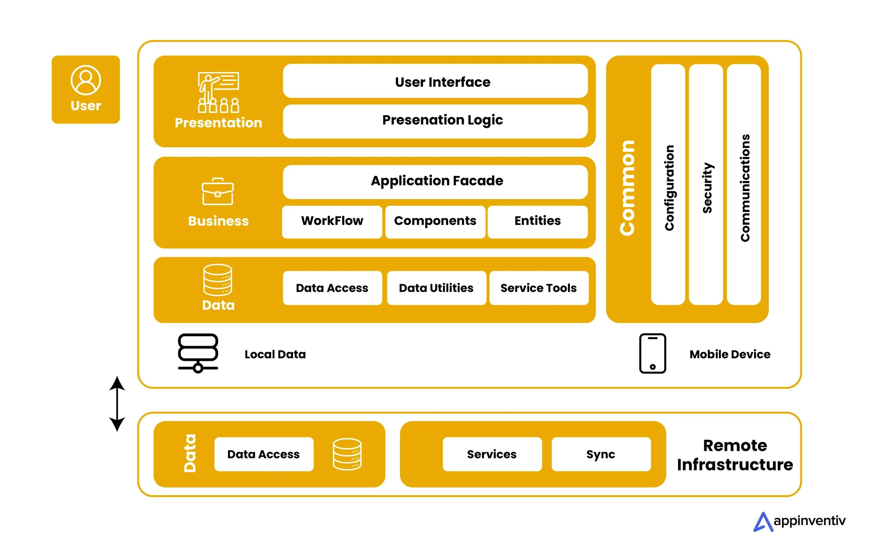

12. Technologies Used
- Frontend: HTML, CSS, JavaScript
- Backend: PHP
- Database: MySQL
- Version Control: GitHub

DIAGRAM ARE AS FOLLOW
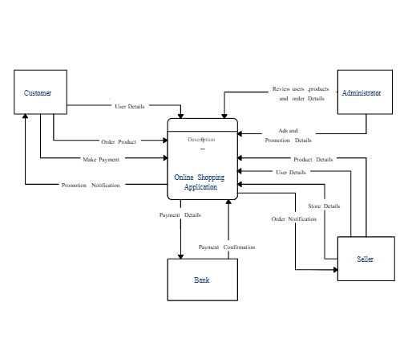

13. Working Process (Simple Flow)
- User logs into the system
- User browses mobile phones
- User adds product to cart
- User places order
- System stores order in database
- Admin manages the order

DIAGRAM ARE AS FOLLOW:

